Schematic diagram:
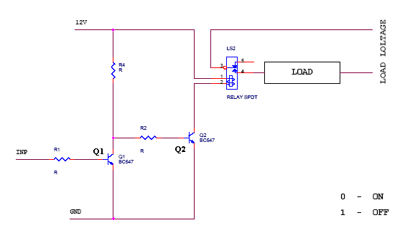
Schematic explanation:

This circuit is designed to control the load. The load may be motor or any other load. The load is turned ON and OFF through relay. The relay ON and OFF is controlled by the pair of switching transistors (BC 547). The relay is connected in the Q2 transistor collector terminal. A Relay is nothing but electromagnetic switching device which consists of three pins. They are Common, Normally close (NC) and Normally open (NO).
The relay common pin is connected to supply voltage. The normally open (NO) pin connected to load. When high (5 Volt)pulse signal is given to base of the Q1 transistors, the transistor is conducting and shorts the collector and emitter terminal and zero (0 Volt)signals is given to base of the Q2 transistor. So the relay is turned OFF state.
When low pulse is given to base of transistor Q1 transistor, the transistor is turned OFF. Now 12v is given to base of Q2 transistor so the transistor is conducting and relay is turned ON. Hence the common terminal and NO terminal of relay are shorted. Now load gets the supply voltage through relay.

Voltage Signal from Transistor Q1 Transistor Q2 Relay
Microcontroller or PC

1 on off off
0 off on on

Relay:
relay is an electrically operated switch. Current flowing through the coil of the relay creates a magnetic field which attracts a lever and changes the switch contacts. The coil current can be on or off so relays have two switch positions and they are double throw (changeover) switches. Relays allow one circuit to switch a second circuit which can be completely separate from the first. For example a low voltage battery circuit can use a relay to switch a 230V AC mains circuit. There is no electrical connection inside the relay between the two circuits; the link is magnetic and mechanical.
The coil of a relay passes a relatively large current, typically 30mA for a 12V relay, but it can be as much as 100mA for relays designed to operate from lower voltages. Most ICs (chips) cannot provide this current and a transistor is usually used to amplify the small IC current to the larger value required for the relay coil.
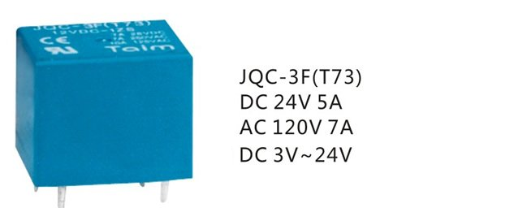
Relays are usually SPDT or DPDT but they can have many more sets of switch contacts, for example relays with 4 sets of changeover contacts are readily available. Most relays are designed for PCB mounting but you can solder wires directly to the pins providing you take care to avoid melting the plastic case of the relay. The picture shows a working relay with its coil and switch contacts. You can see a lever on the left being attracted by magnetism when the coil is switched on. This lever moves the switch contacts. There is one set of contacts (SPDT) in the foreground and another behind them, making the relay DPDT.
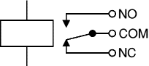
The relay's switch connections are usually labeled COM, NC and NO:
- COM = Common, always connect to this, it is the moving part of the switch.
- NC = Normally Closed, COM is connected to this when the relay coil is off.
- NO = Normally Open, COM is connected to this when the relay coil is on.

COMPONENT DISCRISPTION:

CLASSIFICATION |  | PCB RELAY
Product Model |  | JQC-3F(T73)
Outline Dimension(L×W×H) (mm) |  | 19×15.5×15.5(mm)
Contact Form |  | 1Z,1H,1D
Contact Resistance |  | 100mΩ (1A 6VDC)
Coil Voltage |  | 3VDC~48VDC
Operate Time (at nomi. Volt) |  | 15ms
Release Time (at nomi. Volt) |  | 10ms
Coil Power(W) |  | 0.36
Contact Rating |  | 7A/10A 250VAC 10A/15A 28VDC 10A/15A 120VAC
Insulation Resistance |  | 1000MΩ,500VDC
Dielectric Strengh | Between Open Contact | 500VAC
Dielectric Strengh | Between Coil and Contact | 750VAC
Electrical Life |  | 1×105
Mechanical Life |  | 1×107
Max. Switching Voltage |  | 250VAC/30VDC
Max. Switching Current |  | 15A
Max. Switching Power |  | 300W/2500VA
Impact Resistance |  | Stability 100m/s2 Intensity 1000m/s2
Humidity |  | 35%~95% R.H.
Temperature Range |  | -40~+80°C
Vibration Resistance |  | 1mm 10~55Hz
Mounting Form |  | PCB Terminal
Weight |  | 9g
Construction |  | Sealed IP67

